**Enhanced Interior Gateway Routing Protocol (EIGRP) Configuration**

**Designed Topology:**

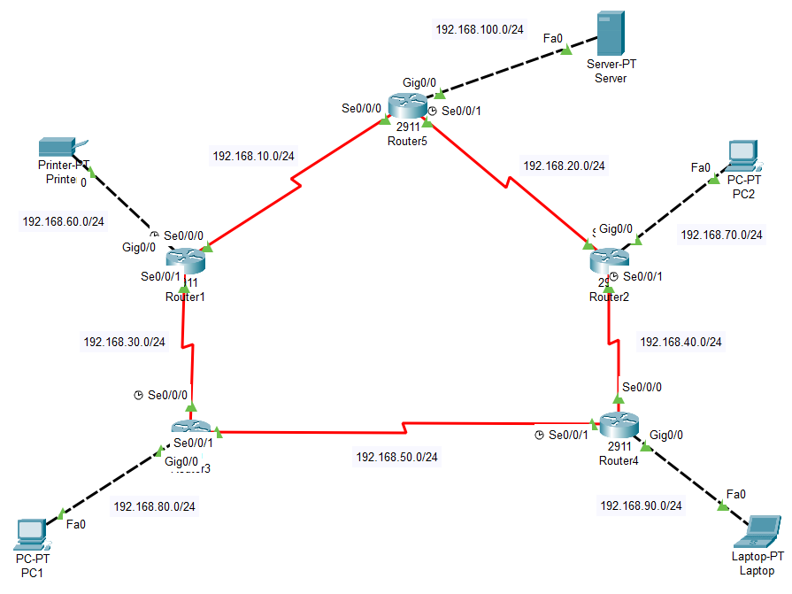

**Configuration of Router1:**

Router>enable

Router#config terminal

Router(config)#hostname R1

R1(config)#int Se0/0/0

R1(config-if)#ip address 192.168.10.2 255.255.255.0

R1(config-if)#clock rate 64000

R1(config-if)#no shutdown

R1(config-if)#exit

R1(config)#int Se0/0/1

R1(config-if)#ip address 192.168.30.1 255.255.255.0

R1(config-if)#no shutdown

R1(config-if)#exit

R1(config)#int Gig0/0

R1(config-if)#ip address 192.168.60.254 255.255.255.0

R1(config-if)#no shutdown

R1(config-if)#ip helper-address 192.168.100.253

R1(config-if)#exit

R1(config)#router eigrp 10

R1(config-router)#network 192.168.10.0 0.0.0.255

R1(config-router)#network 192.168.30.0 0.0.0.255

R1(config-router)#network 192.168.60.0 0.0.0.255

R1(config-router)#no auto-summary

R1(config-router)#exit

R1(config)#service dhcp

R1(config)#exit

R1#write

**Configuration of Router2:**

Router>enable

Router#config terminal

Router(config)#hostname R2

R2(config)#int Se0/0/0

R2(config-if)#ip address 192.168.20.2 255.255.255.0

R2(config-if)#no shutdown

R2(config-if)#exit

R2(config)#int Se0/0/1

R2(config-if)#ip address 192.168.40.1 255.255.255.0

R2(config-if)#clock rate 64000

R2(config-if)#no shutdown

R2(config-if)#exit

R2(config)#int Gig0/0

R2(config-if)#ip address 192.168.70.254 255.255.255.0

R2(config-if)#no shutdown

R2(config-if)#ip helper-address 192.168.100.253

R2(config-if)#exit

R2(config)#router eigrp 10

R2(config-router)#network 192.168.20.0 0.0.0.255

R2(config-router)#network 192.168.40.0 0.0.0.255

R2(config-router)#network 192.168.70.0 0.0.0.255

R2(config-router)#no auto-summary

R2(config-router)#exit

R2(config)#service dhcp

R2(config)#exit

R2#write

**Configuration of Router3:**

Router>enable

Router#config terminal

Router(config)#hostname R3

R3(config)#int Se0/0/0

R3(config-if)#ip address 192.168.30.2 255.255.255.0

R3(config-if)#clock rate 64000

R3(config-if)#no shutdown

R3(config-if)#exit

R3(config)#int Se0/0/1

R3(config-if)#ip address 192.168.50.1 255.255.255.0

R3(config-if)#no shutdown

R3(config-if)#exit

R3(config)#int Gig0/0

R3(config-if)#ip address 192.168.80.254 255.255.255.0

R3(config-if)#no shutdown

R3(config-if)#ip helper-address 192.168.100.253

R3(config-if)#exit

R3(config)#router eigrp 10

R3(config-router)#network 192.168.30.0 0.0.0.255

R3(config-router)#network 192.168.50.0 0.0.0.255

R3(config-router)#network 192.168.80.0 0.0.0.255

R3(config-router)#no auto-summary

R3(config-router)#exit

R3(config)#service dhcp

R3(config)#exit

R3#write

**Configuration of Router4:**

Router>enable

Router#config terminal

Router(config)#hostname R4

R4(config)#int Se0/0/0

R4(config-if)#ip address 192.168.40.2 255.255.255.0

R4(config-if)#no shutdown

R4(config-if)#exit

R4(config)#int Se0/0/1

R4(config-if)#ip address 192.168.50.2 255.255.255.0

R4(config-if)#clock rate 64000

R4(config-if)#no shutdown

R4(config-if)#exit

R4(config)#int Gig0/0

R4(config-if)#ip address 192.168.90.254 255.255.255.0

R4(config-if)#no shutdown

R4(config-if)#ip helper-address 192.168.100.253

R4(config-if)#exit

R4(config)#router eigrp 10

R4(config-router)#network 192.168.40.0 0.0.0.255

R4(config-router)#network 192.168.50.0 0.0.0.255

R4(config-router)#network 192.168.90.0 0.0.0.255

R4(config-router)#no auto-summary

R4(config-router)#exit

R4(config)#service dhcp

R4(config)#exit

R4#write

**Configuration of Router5:**

Router>enable

Router#config terminal

Router(config)#hostname R5

R5(config)#int Se0/0/0

R5(config-if)#ip address 192.168.10.1 255.255.255.0

R5(config-if)#no shutdown

R5(config-if)#exit

R5(config)#int Se0/0/1

R5(config-if)#ip address 192.168.20.1 255.255.255.0

R5(config-if)#clock rate 64000

R5(config-if)#no shutdown

R5(config-if)#exit

R5(config)#int Gig0/0

R5(config-if)#ip address 192.168.100.254 255.255.255.0

R5(config-if)#no shutdown

R5(config-if)#exit

R5(config)#router eigrp 10

R5(config-router)#network 192.168.10.0 0.0.0.255

R5(config-router)#network 192.168.20.0 0.0.0.255

R5(config-router)#network 192.168.100.0 0.0.0.255

R5(config-router)#no auto-summary

R5(config-router)#exit

R5(config)#exit

R5#write

**Displaying information about the routing protocols:**

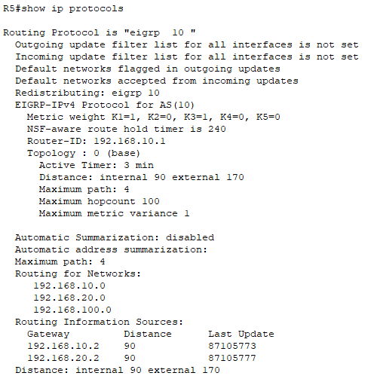

**Displaying the EIGRP topology table:**

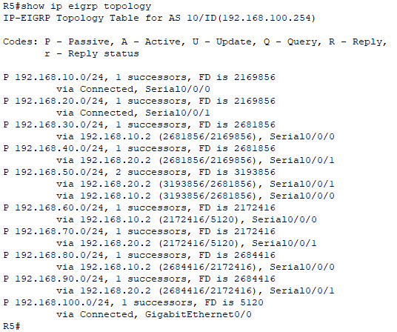

**Displaying information about the interfaces participating in EIGRP:**

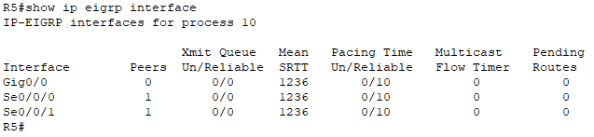

**Displaying list of EIGRP neighbors:**

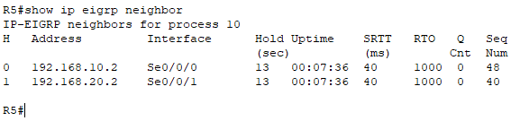

**Displaying the current routing table:**

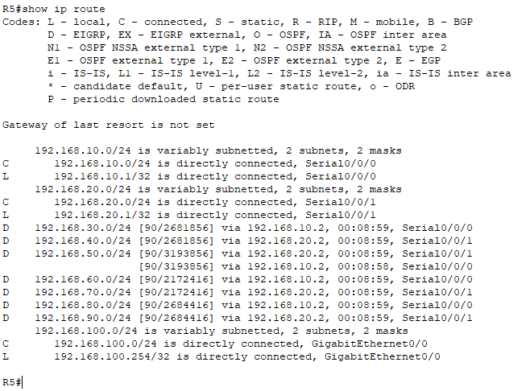

**Displaying the EIGRP routing table:**

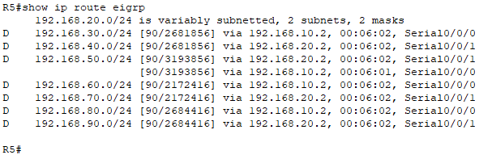

**IP Configuration of Server:**

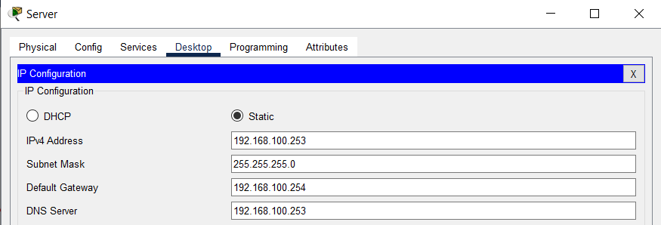

**Creating DHCP Pools:**

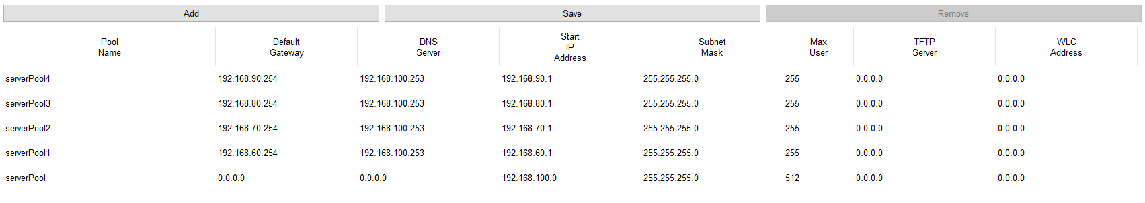

**Configuring DNS Service:**

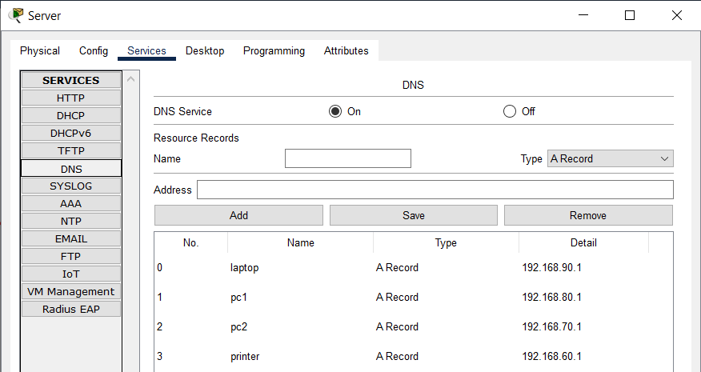

**IP Configuration of PC1:**

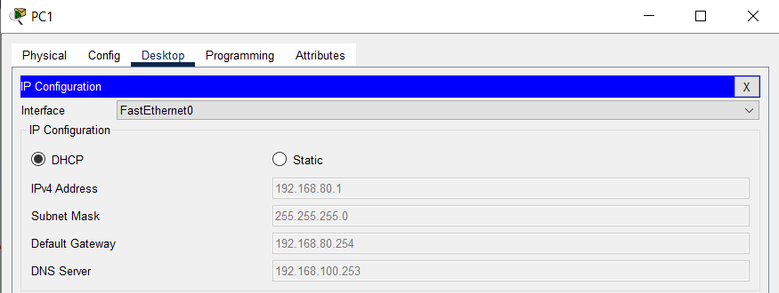

**IP Configuration of PC2:**

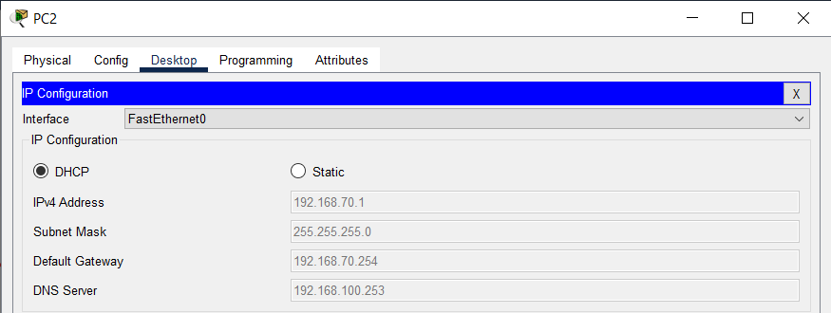

**IP Configuration of Laptop:**

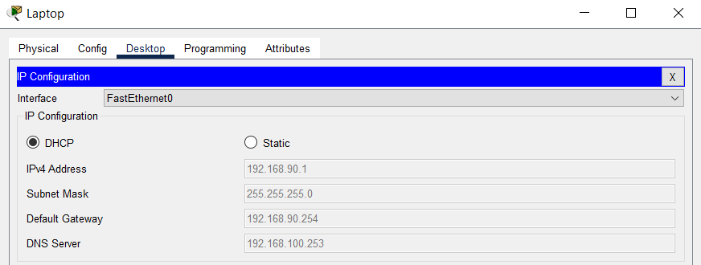

**IP Configuration of Printer:**

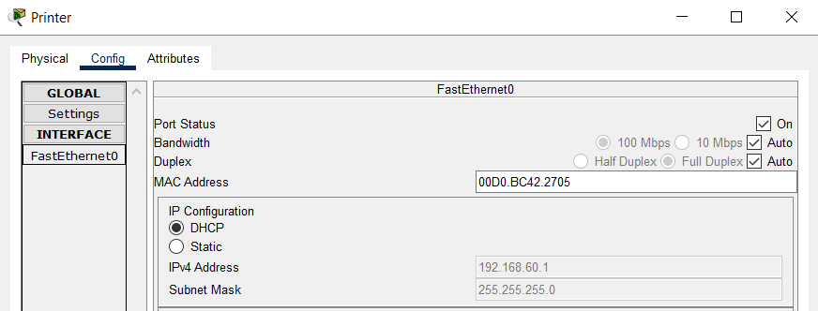

**Checking Connectivity by Pinging:**

**Note:**

EIGRP uses a composite metric, calculated as a function of bandwidth and delay by default. The calculation can also include interface load and interface reliability. You can calculate Metric using below given formula:

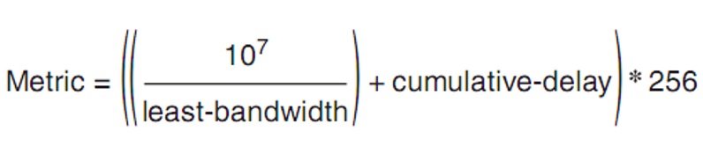

When a route fails and has no feasible successor, EIGRP uses a distributed algorithm called Diffusing Update Algorithm (DUAL). DUAL sends queries looking for a loop-free route to the subnet in question. When the new route is found, DUAL adds it to the routing table.

Replacing a failed route with a feasible successor takes a very short amount of time, typically less than a second or two. When queries and replies are required, convergence can take slightly longer, but in most networks, convergence can still occur in less than 10 seconds.

***A feasible successor is a backup route and stored in the Topology table***